***Xbee Wifi documentation***

**The XBee WiFi Hookup Guide overview includes:**

* XBee WiFi Pinout table
* Choosing an Antenna
* Choosing a Breakout Board

Overview website:

<https://learn.sparkfun.com/tutorials/xbee-wifi-hookup-guide/an-overview>

**XBee WiFi Hookup Guide Using X-CTU includes:**

* How to download X-CTU
* Connecting to a WiFi Network With X-CTU (old version X-CTU)

Using X-CTU website:

<https://learn.sparkfun.com/tutorials/xbee-wifi-hookup-guide/using-x-ctu>

**Steps to connect XBee WiFi with PC through router**

1. Plug your XBee into your XBee Explorer, and plug the Explorer into your computer.

If you haven’t already installed drivers for your Explorer, you may need to do so.

Check out Using X-CTU website.

2. Open X-CTU. The X-CTU application should looks like the figure 1.

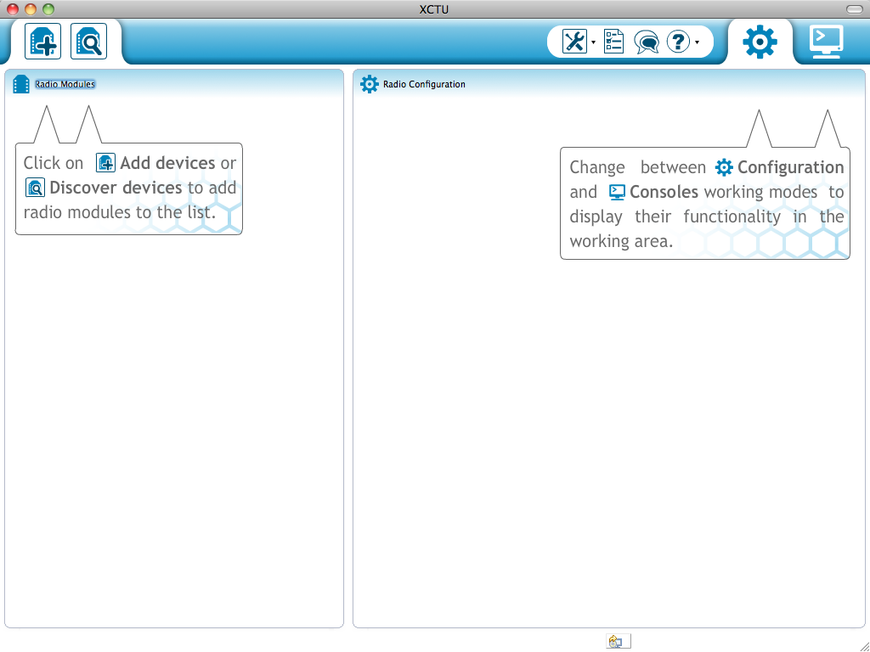

Figure 1: X-CTU Application Open Up Interface

3. Push add radio device button, as shown in figure 2. Add radio device window will pop

out, as shown in figure 3. Pick all the parameters as figure 3. Click Finish. The XBee

WiFi will be discovered, as shown in figure 4.



Figure 2: Radio Device Button

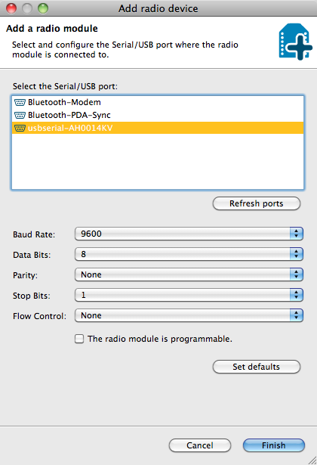

Figure 3: Add Radio Device Window

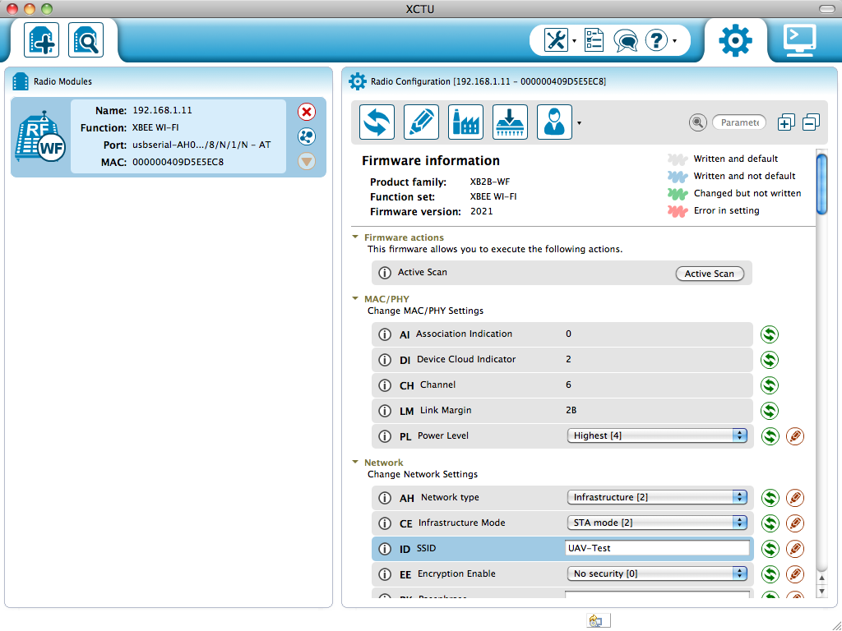

Figure 4: XBee WiFi Discovered Interface

4. Select “Active Scan” in the Firmware actions section. Choose the router’s SSID.

Connect the PC with the router, and check the IP address. The IP address is

192.168.1.2, as shown in figure 5.

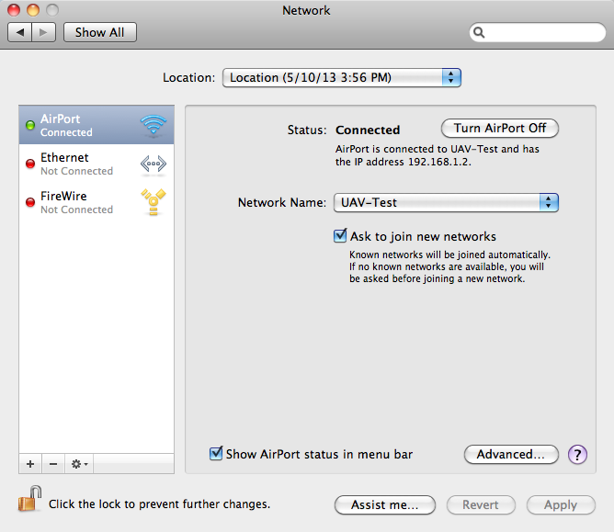

Figure 5: PC Network Preference

5. Change the DL which is the destination IP address to 192.168.1.2. Also change the DE

which is the destination port to 23, as shown in figure 7.

6. Open the PC terminal, as shown in figure 6.

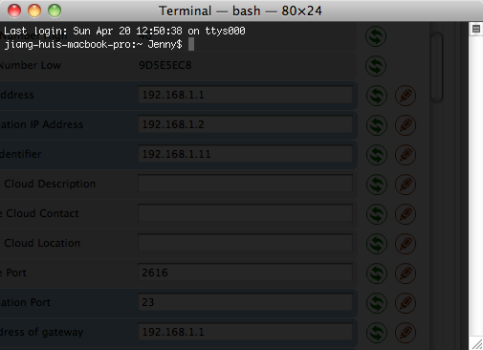

Figure 6: PC Terminal

7. Because the XBee WiFi module IP address is 192.168.1.9, as shown in figure 7.

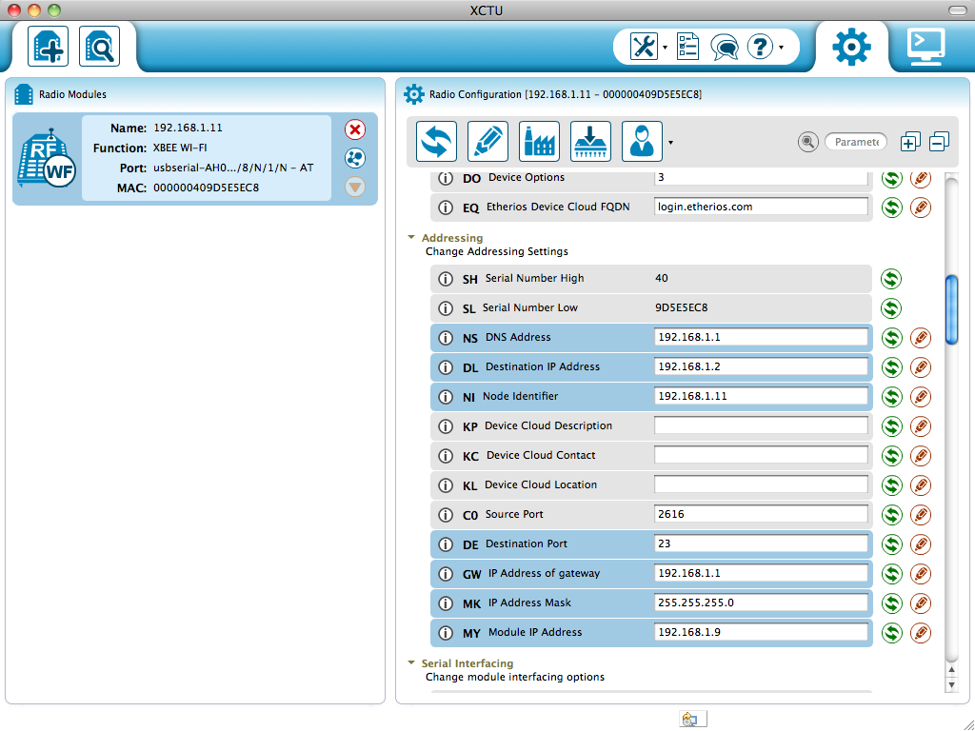

Figure 7: XBee WiFi Module IP Address

8. Type “telnet 192.168.1.9 9750” in the PC terminal.

9. Switch to consoles working mode and close the serial connection with the radio

model, as shown in figure 8.

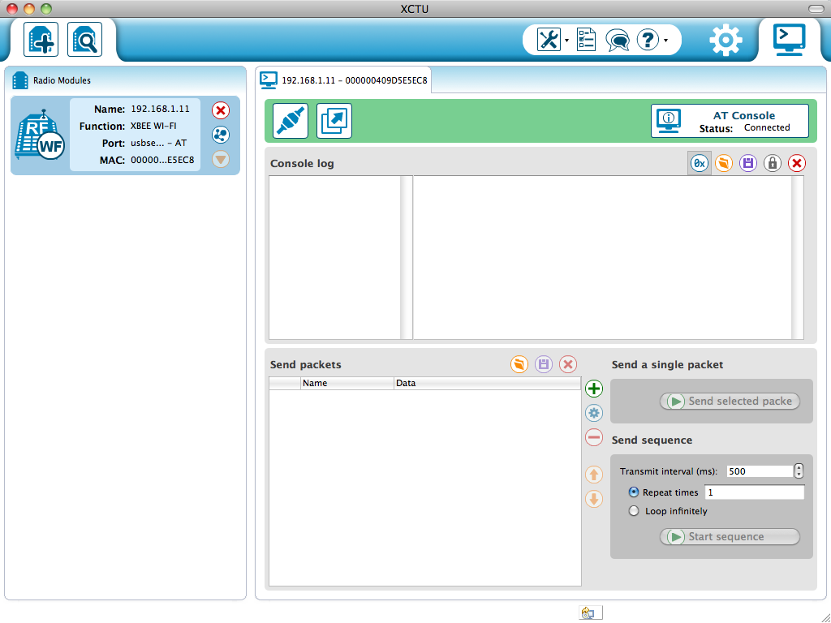

Figure 8: Consoles Working Mode

10. Send single packets to the PC. The PC will receive the message, as shown in figure 9.

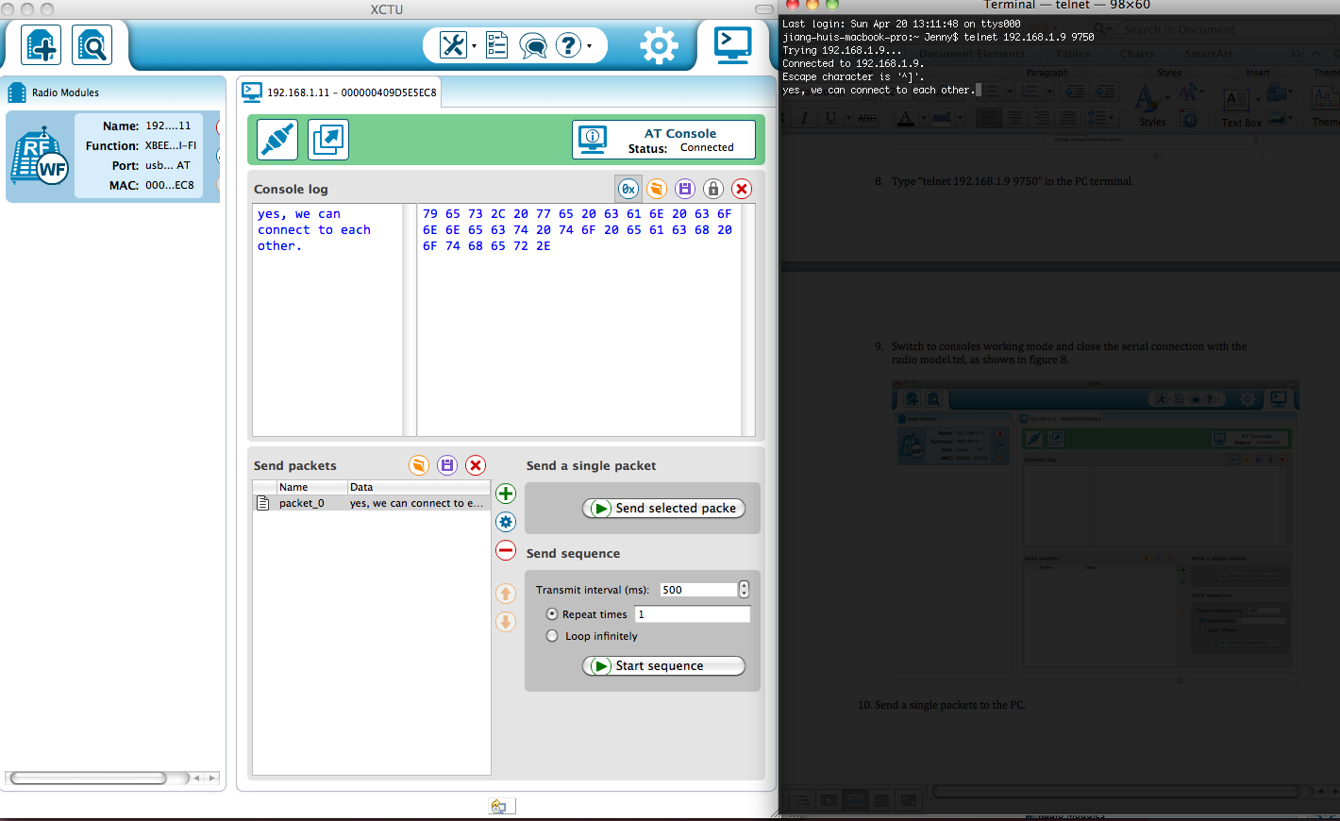

Figure 9: Message Send From XBee WiFi To PC

11. Also, if send message from PC to the XBee WiFi, the XBee WiFi will also receive

the message, as shown in figure 10.

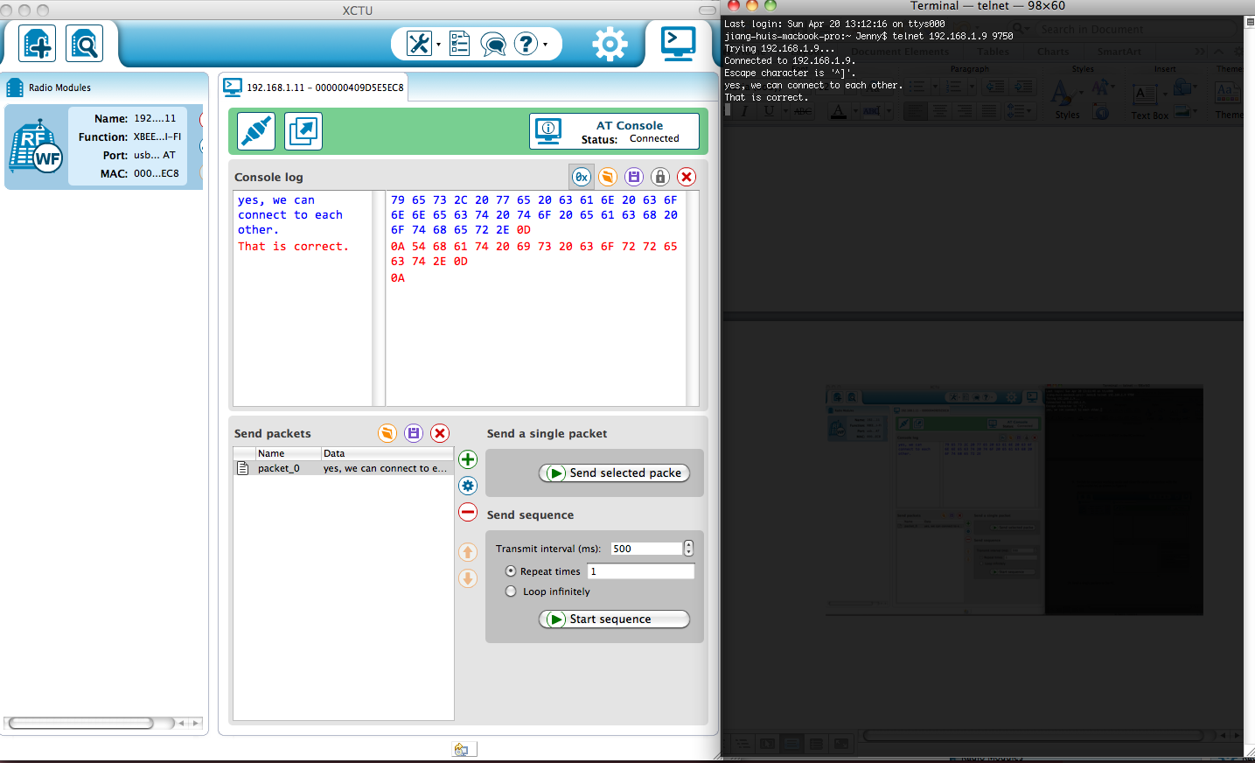

Figure 10: Message Send From PC to XBee WiFi